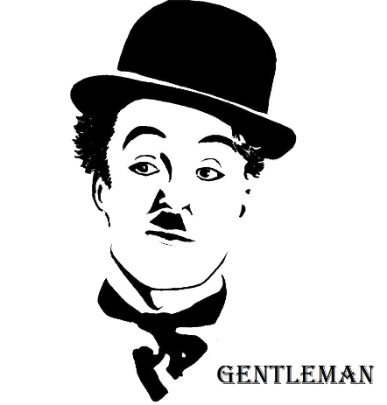

***PROCESS AND QUALITY MANAGEMENT***

***FOR***

***Residential Communication Channel System***

***Version 1.1***

***Team 2 - GENTLEMAN***

***Revision***

|  |  |  |  |
| --- | --- | --- | --- |
| *Author* | *Version* | *Date* | *Content* |
| *Vinh Nguyen* | ***1.1*** | *7/11/2018* | *Initiate Document* |
|  |  |  |  |
|  |  |  |  |
|  |  |  |  |

Table of Contents

***1.*** ***Document Overview*** 2

***a.*** ***Purpose*** 2

***b.*** ***Audience*** 2

***2.*** ***Process Management*** 2

***a.*** ***Planning*** 3

***c.*** ***Design*** 3

***d.*** ***Building*** 3

***e.*** ***Testing*** 4

***3.*** ***Quality Management*** 4

***a.*** ***Planning Process*** 4

***b.*** ***Requirement Process*** 4

***c.*** ***Design Process*** 4

***d.*** ***Building Process*** 4

***e.*** ***Testing Process*** 4

***4.*** ***Reference*** 4

1. ***Document Overview***
   1. ***Purpose***
      * The objective of a document is to identify the process that the GENTLEMAN team will take to develop the project, describing all quality management activities for the current team process.
   2. ***Audience***

|  |  |  |
| --- | --- | --- |
| **Intended Audience** | **Name** | **Reading Suggestions** |
| GENTLEMAN – Team Member | * Manh Truong * Quan Ngo * Hao Vo * Lam To * An Pham | Review Document and report |
| Mentor | * Quoc Nguyen | Review Document |
| Project Manager | * Vinh Nguyen | Initiate and Document Specification |

1. ***Process Management***

The team choose Iterative Approach to develop the project

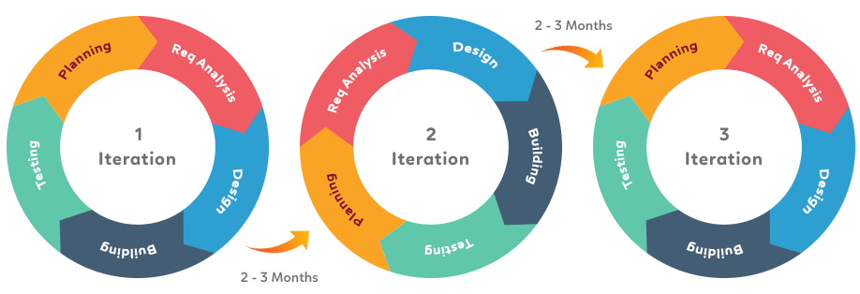

Each iteration will have stages from Requirement Engineering to Testing (similar to Waterfall Model):

* + - Planning
    - Requirement Analysis
    - Design
    - Building
    - Testing

For more detail about each stage above, please refer to RCC_PM_ProjectPlan_ver1.3.docx

1. ***Quality Management***
   1. ***Quality Process***

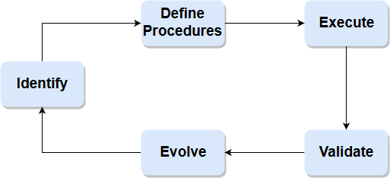

|  |  |
| --- | --- |
| Name | Quality Management Process |
| Purpose | Manage the quality of outputs for each stage |
| Role & Responsibility | Project Manager: responsible for tracking metrics during each stage, make decision to baseline or rework and update Quality Plan, perform evaluation work with Quality Assurance  Quality Assurance: responsible for assure output of each stage must comform with evaluation criteria, perform evaluation work with Project Manager  Project Team: collect and store metrics |
| Process Activities | Identify: Identify goals and estimate effort, schedule for manage quality of current stage  Define Procedures: Define metrics, measure, entry/ exit criteria, storage, report and implement mechanism for quality management  Execute: Collect, analyze, store metrics need to be use to evaluate and update into plan  Validate: Evaluate through compare measure with criteria to make decision  Evolve: Evaluate current plan through measurement of current stage and make decision to improve the Quality Plan |
| Input / Output | Input: Output of stage  Output: Out of that stage has been quality assure |
| Metrics |  |
| Template |  |
| Reference |  |

* 1. ***Planning***

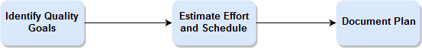

* 1. ***Define Procedures***

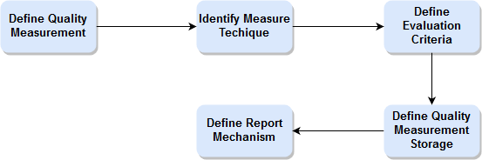

* 1. ***Execute***

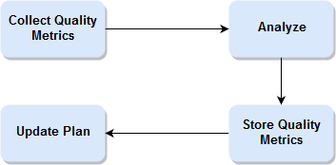

* 1. ***Validate***

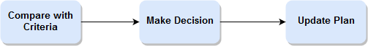

* 1. ***Evolve***

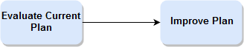

1. ***Reference***

*RCC_PM_ProjectPlan_ver1.3.docx*